(JPEG Image, 2560 x 1920 pixels) - Scaled (47%) https://mail-attachment.googleusercontent.com/attachment/u/O/?ui=2&ik=93bd38e308&vie ...

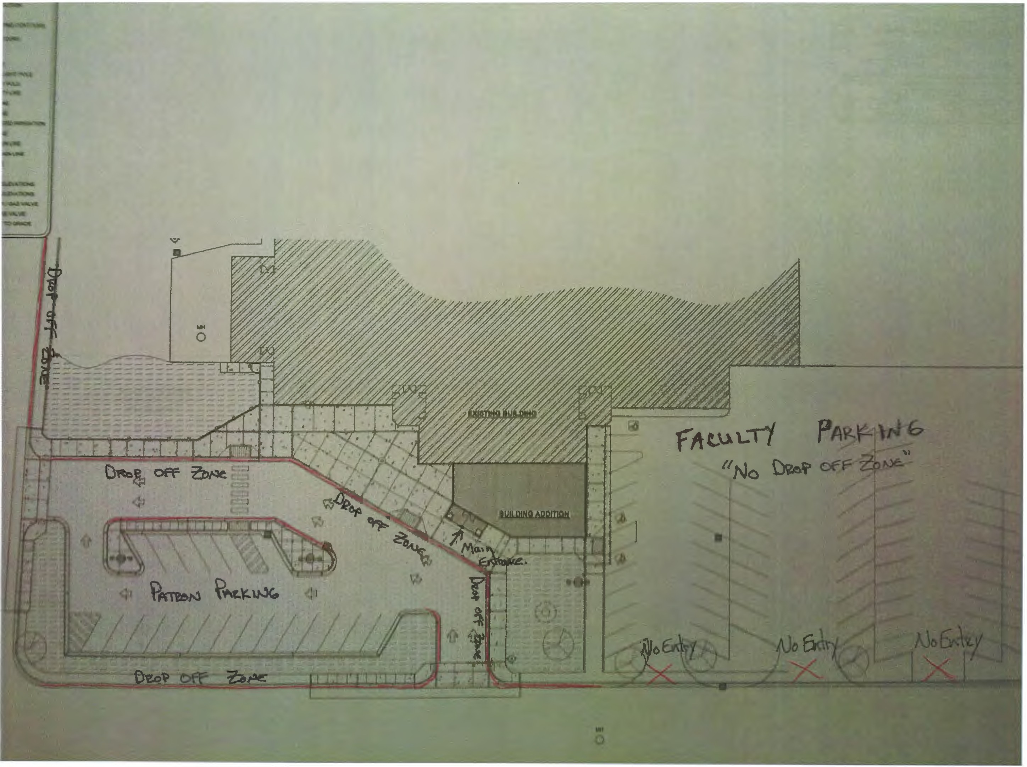

61.v12013 10:27 AM

